# Question 1

(a) Explain the following keyboard layouts:

* QWERTY
* DVORAK

1. QWERTY
   1. Most commonly used.
   2. Inherited from typewriter.
   3. Biased towards left hand.
2. DVORAK
   1. Common letters under dominant fingers
   2. Uses less finger motion and reduces errors compared to standard QWERTY.
   3. Biased towards right hand

(b) *Computer keyboard* layout followed *typewriter keyboard* layout. Why?

* Due to historical reason with typewriter layout being the most commonly used and trained, to help typist to remain productive, reduce the need to relearn typing skills again with computer keyboard, transferable skills from typewritters.
* Also due to industry leader such as IBM and others who chose to use QWERTY.

(c) Describe 2 situations in which *keyboard* might be preferred over *speech* for data entry/issuing command (voice recognition). Briefly explain your answer.

* When typing long sentences in which speech will be much less accurate over typing, when we type, we will look at the sentences, then think is it appropriate or not, when we speak sometimes we don’t think properly, .
* In a noisy open environment where noise interference is possible over speech input, affect the accuracy of the input.
* Its not easy to train the voice recognition systems, a lot of effort and time required, its much more faster for us to input the command into the systems
* You can relate your answers to disadvantages of voice recognition systems

<https://youtu.be/nwPtcqcqz00>

# Question 2

(a) Describe 2 situations in which *speech* might be preferred over *keyboard* for data entry/issuing command. Briefly explain your answer.

* With a phone when user is preoccupied with other actions such as when driving.
* When users have physical/visual disabilities, the user cannot see.
* When a command is short and an interface is designed towards untrained novice users. This reduces chance of error and at the same time allowing repeat “cost” to be low.
* You can relate your answers to the advantages of voice recognition

(b) Explain why thermal printer is a better choice for ATM machines.

* Low maintenance as there is no need to replace consumables.
* Less maintenance cost as there is less movable parts compared to other printers.
* A major advantage of using thermal paper is that it requires**almost no maintenance**; there is no expensive ink or toner to constantly replace. The only maintenance required is to occasionally wipe the printer head to keep it clean. Maintenance cost is further reduced because complicated repairs are seldom necessary. An inkless thermal paper printer has very few moving parts, which makes it highly unlikely to jam compared to other printer types. This saves a lot of money through lower maintenance costs.
* Thermal printing produces an image much, much faster than regular paper. Thermal printing heads produce images **in milliseconds**, which results in more lines per second, and the images dry instantly. This increased speed enables faster printing of receipts for customers, saving them valuable time waiting in line.
* Thermal paper has a smooth, even coating on its surface. When passed through the heated printer head, the coating “cells” on the paper surface have a chemical reaction and form a **high definition image**. This process uses no ink, so you do not have to worry about smears and smudges, which could make the image or words challenging to read.
* thermal papers use heat to produce the images, no ink, cartridges, or toner is needed. Businesses and industries can save a significant amount of money by using thermal paper. In thermal printing, thermal paper is **the only consumable** needed.
* Thermal printers have very few moving parts, which makes them much more **reliable and durable** than ink printers. Thermal printers almost never jam, and even under the pressure of a constant, heavy workload, a quality thermal printer will consistently produce sharp, durable images, day after day, that are very resistant to climate, soils, UV rays and other damage.
* You can look at the advantages of thermal printers as your asnwers

## **Question 3 *(Present your answers using PowerPoint slides)***

(a) *“If a fill-in form have both text entry fields and multiple-choice selection fields then each input type should be grouped together.”*

Do you agree with the above statement? Give reasons and an example (**own example**) to support your answer.

No.

Forms are separated into different sections and each section has its own context. Grouping the controls would break the context layout.

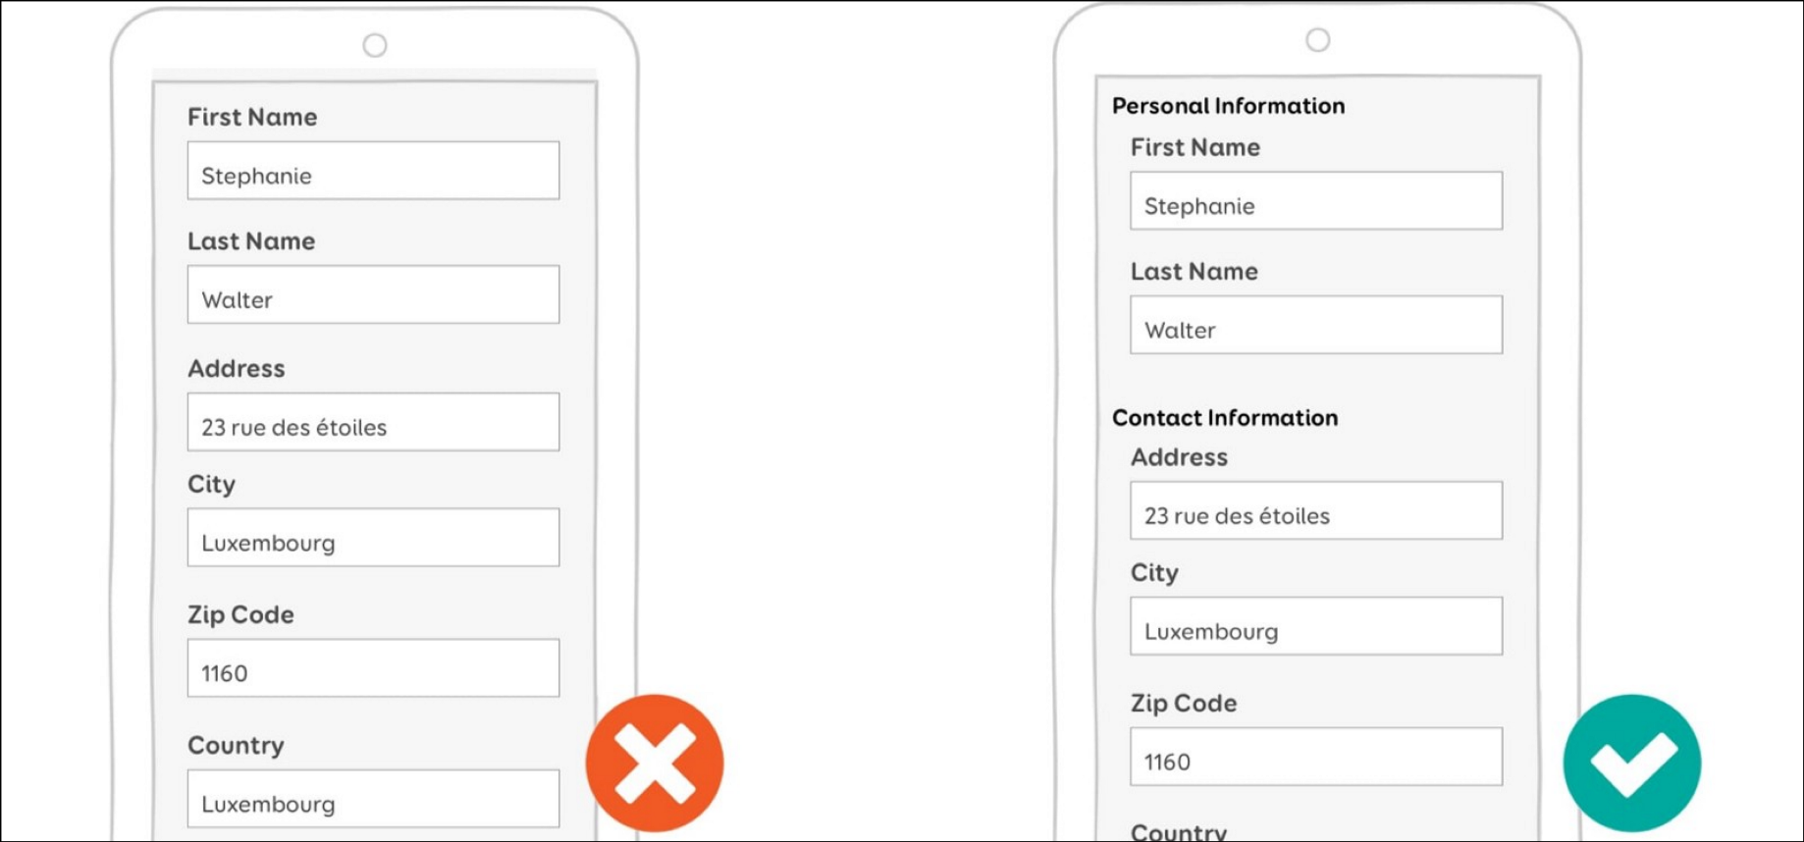

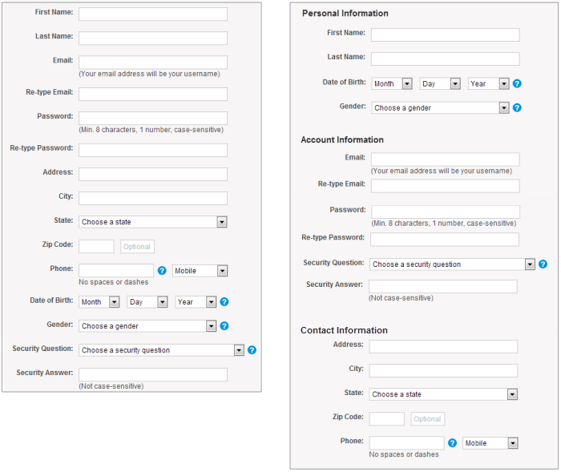

However, if there is no such conflict, then it would be good to group the controls together in order to minimize hands movements when using input/output devices and also eye movements.

(b) Watch <https://www.youtube.com/watch?v=jbV5dGvJWyo>

Based on the video, list some of the common sense things that you should do to avoid neck, shoulder, arm and leg pains as well as eyestrains when using a computer. In other words, give advice on how to avoid health problems when using a computer.

* Use input devices that are ergonomic such as ergonomic mouse and keyboards.
* UI should be designed such that it minimizes hand movements within IO devices.
* Eye should be level with computer screen.
* Arms should be placed close to keyboard without body leaning forward.
* Sit straight without body hunching or slouching.

(c) Find a similar video in youtube and **share** it with everyone in the class.

<https://youtu.be/sXJI4Nzr4_8>

Video title: _______________________________________________